Drew Scheessele

Canvas Final Design and Product Recommendations

I. Introduction
Project overview & problem statement
Students reported that core course information, such as announcements, grades, assignments and new modules are scattered across multiple Canvas screens and labeled inconsistently by different instructors. This resulted in inefficient user paths and information delivery that force students to bounce from course to course adding unnecessary clicks that would drill down into the site’s information architecture and cognitive load.
Design Goals
- Centralize course updates in one location that is visible on every page.
- Lower the average navigation path to new content to two clicks or fewer.
- Preserve familiar Canvas functions while adding clear visual cues for actionability and status.
User-research Methods & Key Insights
For this project, user research occurred through a couple of different ways. First, personas were created and informal interviews took place to understand users’ needs for Canvas and where there pain points were. My findings from these interviews were that pain points when using Canvas largely were from having to go through the different course menus in order to find different pages that they would looking for, causing a lot of repeated actions, just different courses.
Next, I performed a moderated paper prototype test with users of a proposed solution of an ever-present Notification box that could be used for navigation between multiple courses, focusing on assignments, announcements, grades, and modules. This test allowed me to learn that the users felt that they were “drilling down” too much, despite the new option, but they liked being able to move from the assignment page of one course directly to the assignment page of another.
Lastly, I performed an AI moderated usability test with the assistance of Strella on a mid-fidelity prototype built with Figma. This test involved 3 students as participants and they each performed 3 tasks. From this, I found that users preferred the new notification menu over the traditional navigation paths through courses on Canvas. There were some adjustments to still be made, such as adding color-coding for urgency and clearer cues for new items.

II. Design Solution
Final Design
A persistent Notification Box, opened from the existing bell icon (now carrying a live unread-item badge), lists recent announcements, assignments, modules and grades from all enrolled courses. A funnel icon toggles a filter panel; which turns blue when filters are active to match Canvas’ “New Activity” brand color. Links are underlined to reinforce click-ability, and each list item links directly to the target screen. This allows users to quickly switch between one course’s items to the next, bypassing the default course menu and homepage.
Interactive prototype
https://www.figma.com/proto/tQYP4FhYOhKPhrxKndibxK/Untitled?node-id=1-68&t=ZVS1BQuKJTfXdql1-1&scaling=min-zoom&content-scaling=fixed&page-id=0%3A1&starting-point-node-id=1%3A62
Annotated screens - dashboard with unread badge, filter-open state, item-detail view (see Appendix A in prototype).
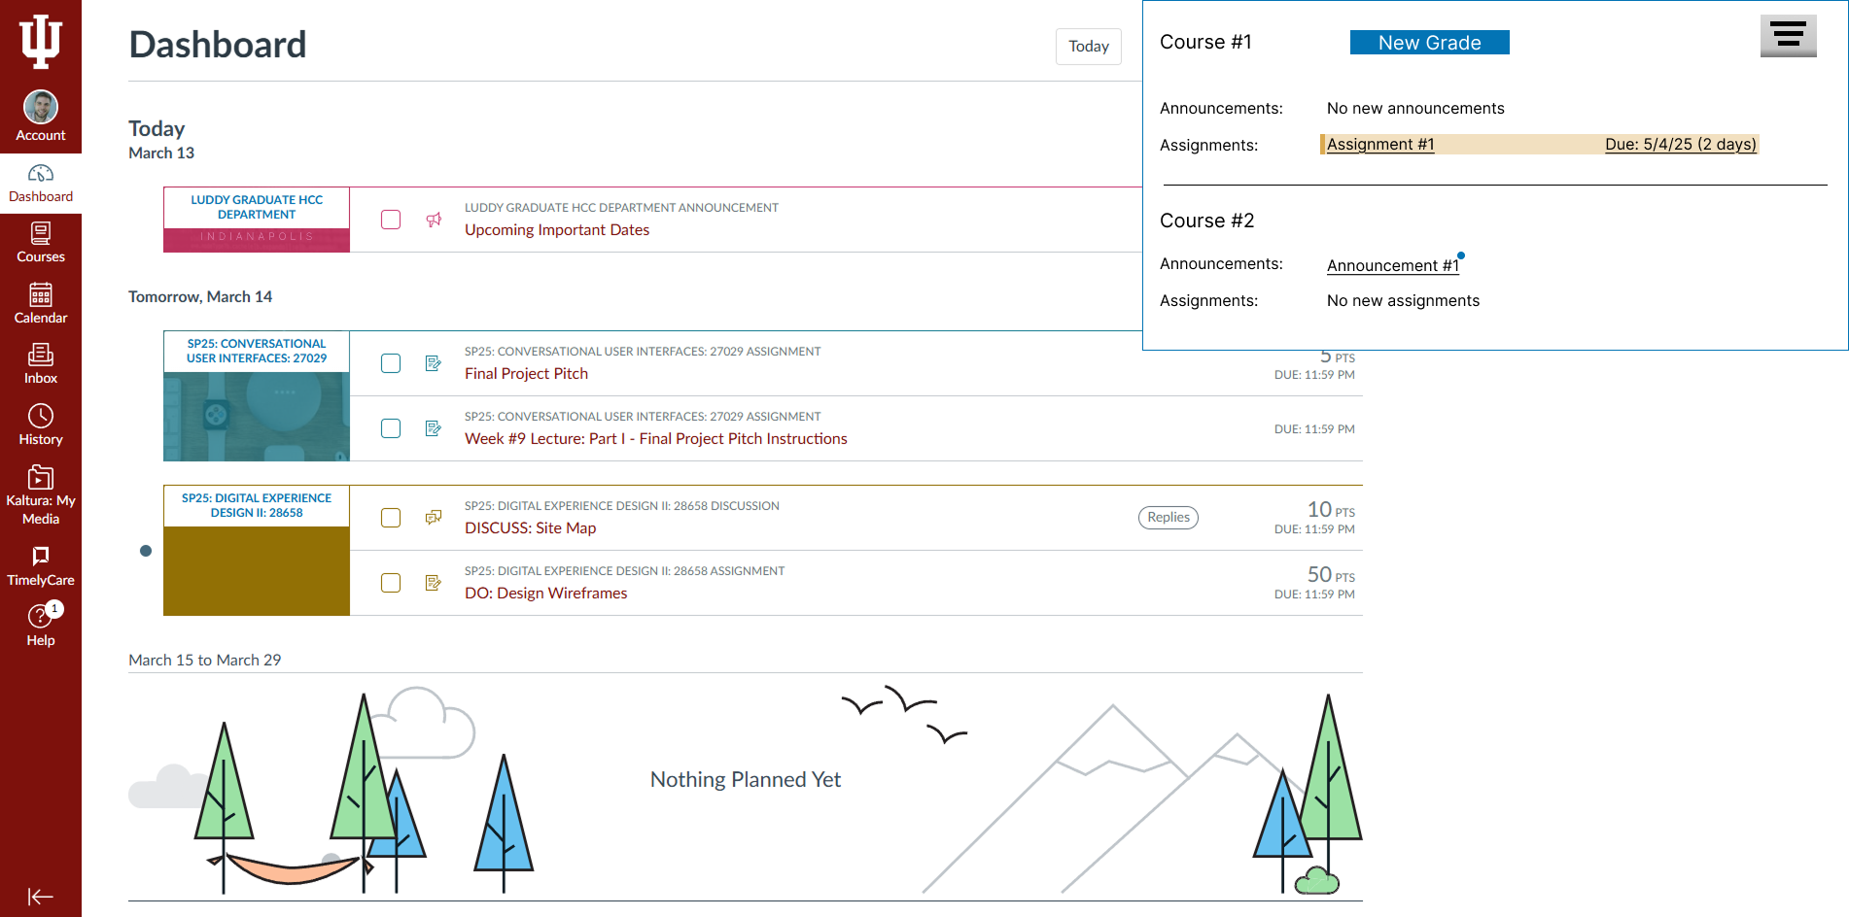
This screen depicts the Dashboard, with the new notifications box open, showcasing the options for announcements, assignments, and the “New Grade” button for two courses. The yellow highlight on the assignment signifies that the due date is coming soon, on the day that the assignment is due, this would turn red. This color-coding was implemented to address a user request that resulted from my testing with Strella. This supports prioritization, allowing the user to learn information quickly about their assignments.
The items that are underlined signify that these are clickable links. During user testing in the paper prototype, the user didn’t understand that they would be able to click on these items at first without them being underlined.

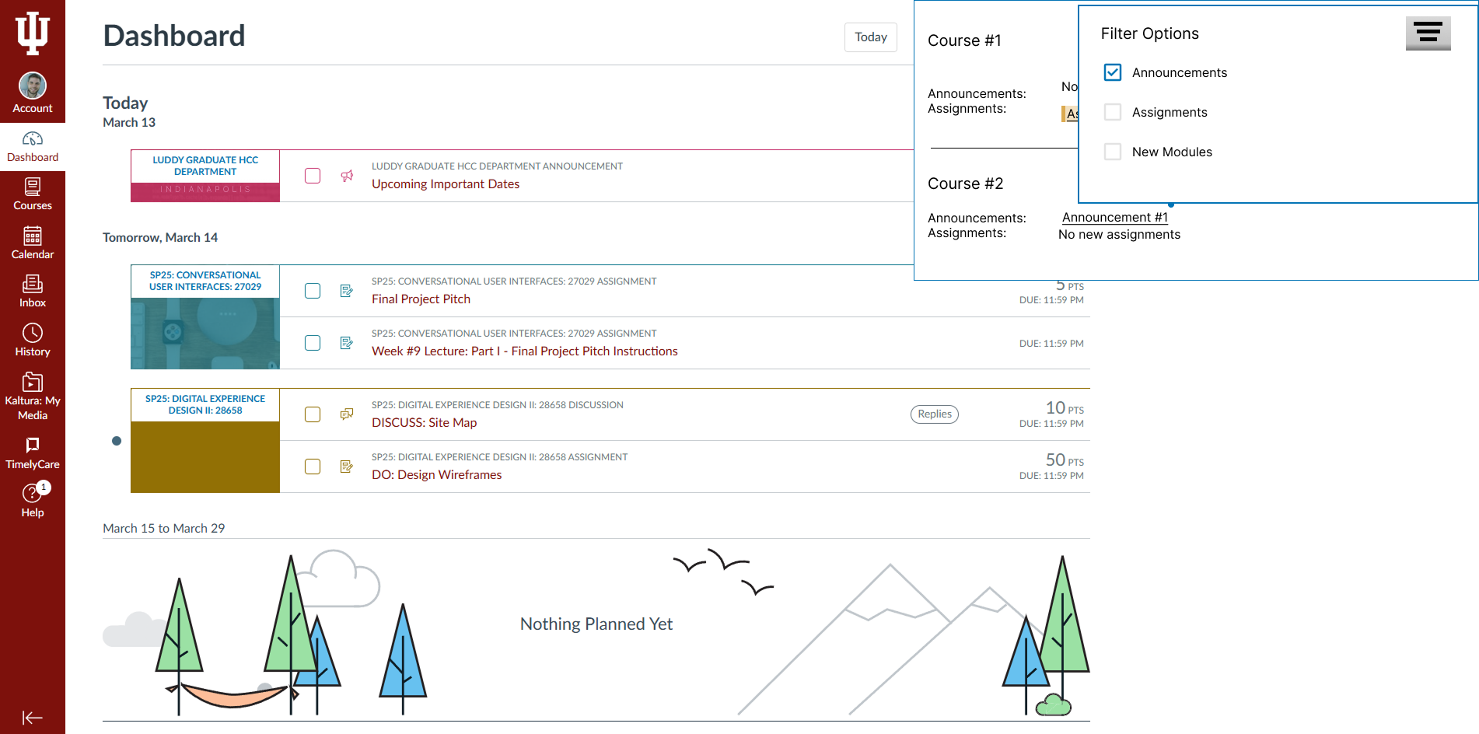
This image depicts the “Filters” menu opened to display the different options that the user can sort by.
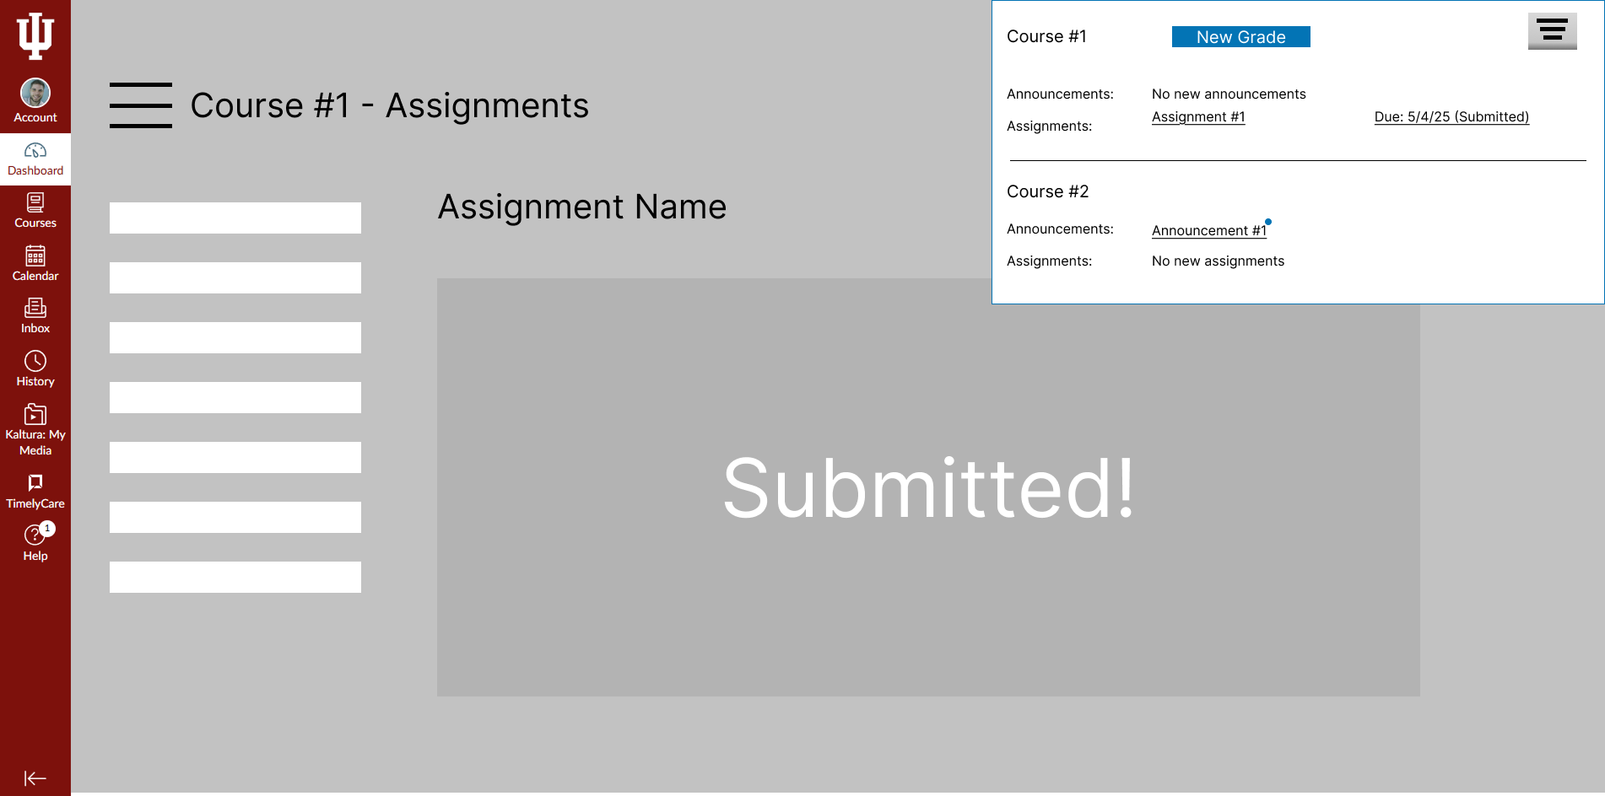
Once the assignment is submitted, the yellow or red highlight is removed and the due date countdown is replaced with “(Submitted)”.

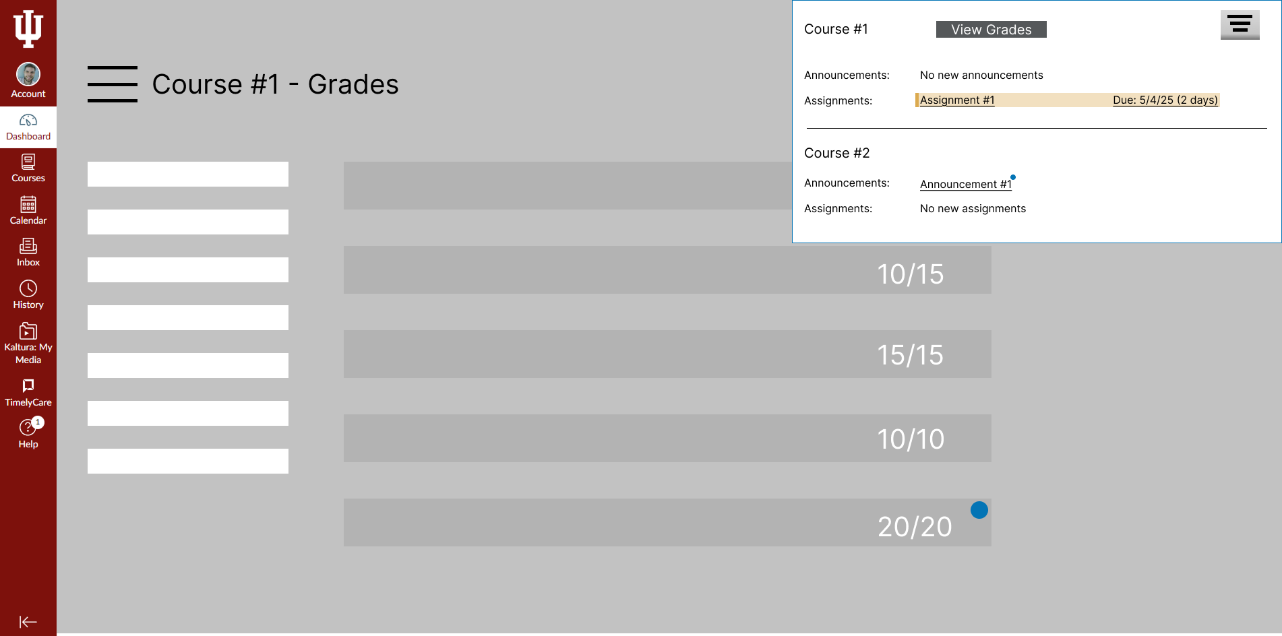
Once the new grade is viewed for a course, the button turns grey and the text changes to “View Grades” to signify that the new item has been viewed.

III. Product Requirements

1. Functional
- Global bell icon with dynamic unread-count badge.
- Notification Box loads on every Canvas page.
- List groups by course; each item includes title, due/posted date, and link.
- Multi-select filter panel (Announcements, Assignments, Modules, Grades).
- Filters auto-disable when item is not available.
- Set filters and options save as user goes across each webpage.

2. Non-functional
- Compatible with latest versions of Chrome, Safari, Firefox, Edge.
- No personal information displayed, follows Canvas authentication model.

3. Usability
- Less than or equal to 2 clicks from any Canvas screen to the target content listed in Notification Box.
- Familiar iconography (bell, funnel) and link underlines.
- Color-coded due dates (Yellow with 72-24 hours before due date, Red 24 hours before due date).
- Blue ping icon for new items, such as new announcements.

4. Accessibility
- Meet WCAG color contrast and accessibility requirements.
- Fully operated by keyboard (Tab into list, Arrow navigate items, Enter activate).
- Compatibility with Screen Readers.

5. Future iterations & enhancements
- Fully collapsible course sections for hiding unneeded information..
- Option to mute specific courses or categories.
- Further depth to list items, possibly include details of an item on hover.

V. Conclusion
The Notification Box concept consolidates critical course updates into a single, always-available component, cutting navigation time, reducing cognitive load and accommodating varied instructor practices. Early user testing shows a clear preference for the new workflow and validates the design’s potential to improve student satisfaction and course engagement while requiring minimal change to Canvas’ existing UI form and function. Stakeholders, including students and instructors, benefit from faster task completion, clearer status visibility, and a design system that fits neatly into Canvas’ brand.

